**Week -2 HandsOn Solutions (Mandatory)**

**PL/SQL**

**Exercise:1 Control Structures**

Program

-- Step 1: Create tables only if not exists

BEGIN

EXECUTE IMMEDIATE '

CREATE TABLE customers (

customer_id NUMBER PRIMARY KEY,

name VARCHAR2(100),

age NUMBER,

balance NUMBER(10,2),

is_vip CHAR(1) DEFAULT ''N''

)';

EXCEPTION

WHEN OTHERS THEN

IF SQLCODE != -955 THEN -- -955: object already exists

RAISE;

END IF;

END;

/

BEGIN

EXECUTE IMMEDIATE '

CREATE TABLE loans (

loan_id NUMBER PRIMARY KEY,

customer_id NUMBER,

interest_rate NUMBER(5,2),

due_date DATE,

FOREIGN KEY (customer_id) REFERENCES customers(customer_id)

)';

EXCEPTION

WHEN OTHERS THEN

IF SQLCODE != -955 THEN

RAISE;

END IF;

END;

/

-- Step 2: Upsert sample data (avoids duplicate primary key error)

MERGE INTO customers c

USING (SELECT 1 AS customer_id, 'Alice' AS name, 65 AS age, 12000 AS balance, 'N' AS is_vip FROM dual) src

ON (c.customer_id = src.customer_id)

WHEN NOT MATCHED THEN

INSERT (customer_id, name, age, balance, is_vip)

VALUES (src.customer_id, src.name, src.age, src.balance, src.is_vip);

MERGE INTO customers c

USING (SELECT 2 AS customer_id, 'Bob' AS name, 45 AS age, 8000 AS balance, 'N' AS is_vip FROM dual) src

ON (c.customer_id = src.customer_id)

WHEN NOT MATCHED THEN

INSERT (customer_id, name, age, balance, is_vip)

VALUES (src.customer_id, src.name, src.age, src.balance, src.is_vip);

MERGE INTO customers c

USING (SELECT 3 AS customer_id, 'Charlie' AS name, 70 AS age, 5000 AS balance, 'N' AS is_vip FROM dual) src

ON (c.customer_id = src.customer_id)

WHEN NOT MATCHED THEN

INSERT (customer_id, name, age, balance, is_vip)

VALUES (src.customer_id, src.name, src.age, src.balance, src.is_vip);

MERGE INTO loans l

USING (SELECT 101 AS loan_id, 1 AS customer_id, 7.5 AS interest_rate, SYSDATE + 15 AS due_date FROM dual) src

ON (l.loan_id = src.loan_id)

WHEN NOT MATCHED THEN

INSERT (loan_id, customer_id, interest_rate, due_date)

VALUES (src.loan_id, src.customer_id, src.interest_rate, src.due_date);

MERGE INTO loans l

USING (SELECT 102 AS loan_id, 2 AS customer_id, 6.0 AS interest_rate, SYSDATE + 45 AS due_date FROM dual) src

ON (l.loan_id = src.loan_id)

WHEN NOT MATCHED THEN

INSERT (loan_id, customer_id, interest_rate, due_date)

VALUES (src.loan_id, src.customer_id, src.interest_rate, src.due_date);

MERGE INTO loans l

USING (SELECT 103 AS loan_id, 3 AS customer_id, 8.0 AS interest_rate, SYSDATE + 5 AS due_date FROM dual) src

ON (l.loan_id = src.loan_id)

WHEN NOT MATCHED THEN

INSERT (loan_id, customer_id, interest_rate, due_date)

VALUES (src.loan_id, src.customer_id, src.interest_rate, src.due_date);

/

-- Step 3: Main Logic Block (All 3 Scenarios)

BEGIN

DBMS_OUTPUT.PUT_LINE('--- Scenario 1: Interest Discount for Customers Above 60 ---');

FOR cust IN (

SELECT c.customer_id, c.name, l.loan_id

FROM customers c

JOIN loans l ON c.customer_id = l.customer_id

WHERE c.age > 60

) LOOP

UPDATE loans

SET interest_rate = interest_rate - (interest_rate * 0.01)

WHERE loan_id = cust.loan_id;

DBMS_OUTPUT.PUT_LINE('✔ Discount applied to ' || cust.name || ' for Loan ID: ' || cust.loan_id);

END LOOP;

DBMS_OUTPUT.PUT_LINE(CHR(10) || '--- Scenario 2: Promote Customers to VIP ---');

FOR cust IN (

SELECT customer_id, name, balance

FROM customers

WHERE balance > 10000 AND is_vip = 'N'

) LOOP

UPDATE customers

SET is_vip = 'Y'

WHERE customer_id = cust.customer_id;

DBMS_OUTPUT.PUT_LINE('✔ Customer ' || cust.name || ' promoted to VIP. Balance: $' || cust.balance);

END LOOP;

DBMS_OUTPUT.PUT_LINE(CHR(10) || '--- Scenario 3: Loan Due Reminders ---');

FOR loan_rec IN (

SELECT l.loan_id, c.name, l.due_date

FROM loans l

JOIN customers c ON l.customer_id = c.customer_id

WHERE l.due_date <= SYSDATE + 30

) LOOP

DBMS_OUTPUT.PUT_LINE('📢 Reminder: Loan ID ' || loan_rec.loan_id || ' for ' || loan_rec.name ||

' is due on ' || TO_CHAR(loan_rec.due_date, 'DD-Mon-YYYY'));

END LOOP;

END;

/

Output:

Exercise:3 Stored Procedures

-- Step 1: Create Tables (if not exists)

BEGIN

EXECUTE IMMEDIATE 'CREATE TABLE savings_accounts (

account_id NUMBER PRIMARY KEY,

customer_id NUMBER,

balance NUMBER(10,2)

)';

EXCEPTION

WHEN OTHERS THEN IF SQLCODE != -955 THEN RAISE; END IF;

END;

/

BEGIN

EXECUTE IMMEDIATE 'CREATE TABLE employees (

employee_id NUMBER PRIMARY KEY,

name VARCHAR2(100),

department VARCHAR2(50),

salary NUMBER(10,2)

)';

EXCEPTION

WHEN OTHERS THEN IF SQLCODE != -955 THEN RAISE; END IF;

END;

/

BEGIN

EXECUTE IMMEDIATE 'CREATE TABLE bank_accounts (

account_id NUMBER PRIMARY KEY,

customer_id NUMBER,

balance NUMBER(10,2)

)';

EXCEPTION

WHEN OTHERS THEN IF SQLCODE != -955 THEN RAISE; END IF;

END;

/

-- Step 2: Sample Data (MERGE avoids duplicate insert errors)

MERGE INTO savings_accounts s

USING (SELECT 1 account_id, 101 customer_id, 1000 balance FROM dual) d

ON (s.account_id = d.account_id)

WHEN NOT MATCHED THEN INSERT (account_id, customer_id, balance)

VALUES (d.account_id, d.customer_id, d.balance);

MERGE INTO savings_accounts s

USING (SELECT 2 account_id, 102 customer_id, 2000 balance FROM dual) d

ON (s.account_id = d.account_id)

WHEN NOT MATCHED THEN INSERT (account_id, customer_id, balance)

VALUES (d.account_id, d.customer_id, d.balance);

MERGE INTO employees e

USING (SELECT 1 employee_id, 'John' name, 'IT' department, 50000 salary FROM dual) d

ON (e.employee_id = d.employee_id)

WHEN NOT MATCHED THEN INSERT (employee_id, name, department, salary)

VALUES (d.employee_id, d.name, d.department, d.salary);

MERGE INTO employees e

USING (SELECT 2 employee_id, 'Jane' name, 'HR' department, 45000 salary FROM dual) d

ON (e.employee_id = d.employee_id)

WHEN NOT MATCHED THEN INSERT (employee_id, name, department, salary)

VALUES (d.employee_id, d.name, d.department, d.salary);

MERGE INTO bank_accounts b

USING (SELECT 101 account_id, 1 customer_id, 3000 balance FROM dual) d

ON (b.account_id = d.account_id)

WHEN NOT MATCHED THEN INSERT (account_id, customer_id, balance)

VALUES (d.account_id, d.customer_id, d.balance);

MERGE INTO bank_accounts b

USING (SELECT 102 account_id, 1 customer_id, 1500 balance FROM dual) d

ON (b.account_id = d.account_id)

WHEN NOT MATCHED THEN INSERT (account_id, customer_id, balance)

VALUES (d.account_id, d.customer_id, d.balance);

/

-- Step 3: Stored Procedure 1: ProcessMonthlyInterest

CREATE OR REPLACE PROCEDURE ProcessMonthlyInterest AS

BEGIN

FOR acc IN (SELECT account_id, balance FROM savings_accounts) LOOP

UPDATE savings_accounts

SET balance = balance + (balance * 0.01)

WHERE account_id = acc.account_id;

END LOOP;

DBMS_OUTPUT.PUT_LINE('✔ Monthly interest processed for all savings accounts.');

END;

/

-- Step 4: Stored Procedure 2: UpdateEmployeeBonus

CREATE OR REPLACE PROCEDURE UpdateEmployeeBonus(

dept_name IN VARCHAR2,

bonus_percent IN NUMBER

) AS

BEGIN

UPDATE employees

SET salary = salary + (salary * bonus_percent / 100)

WHERE department = dept_name;

DBMS_OUTPUT.PUT_LINE('✔ Bonus of ' || bonus_percent || '% applied to department: ' || dept_name);

END;

/

-- Step 5: Stored Procedure 3: TransferFunds

CREATE OR REPLACE PROCEDURE TransferFunds(

from_account IN NUMBER,

to_account IN NUMBER,

amount IN NUMBER

) AS

from_balance NUMBER;

BEGIN

SELECT balance INTO from_balance FROM bank_accounts WHERE account_id = from_account FOR UPDATE;

IF from_balance < amount THEN

RAISE_APPLICATION_ERROR(-20001, '❌ Insufficient funds in source account.');

END IF;

UPDATE bank_accounts SET balance = balance - amount WHERE account_id = from_account;

UPDATE bank_accounts SET balance = balance + amount WHERE account_id = to_account;

DBMS_OUTPUT.PUT_LINE('✔ Transferred ₹' || amount || ' from account ' || from_account || ' to ' || to_account);

END;

/

-- Step 6: Procedure Execution (Test Calls)

BEGIN

DBMS_OUTPUT.PUT_LINE('--- Running Stored Procedures ---');

-- 1. Apply Monthly Interest

ProcessMonthlyInterest;

-- 2. Update Bonus for IT Dept

UpdateEmployeeBonus('IT', 10); -- 10% bonus

-- 3. Transfer ₹500 from account 101 to 102

TransferFunds(101, 102, 500);

END;

/

Output:

**Junit basic testing exercises**

Exercise:1 Setting up Junit

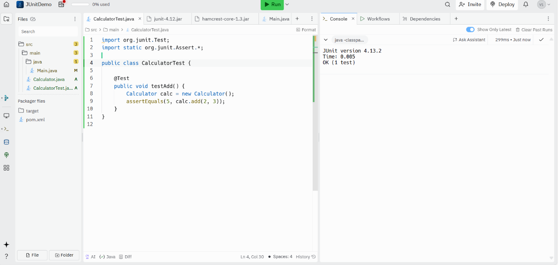

Exercise:3 Assertions in Junit

Exercise :4 Arrange-Act-Assert (AAA) Pattern, Test Fixtures, Setup and Teardown Methods in Junit

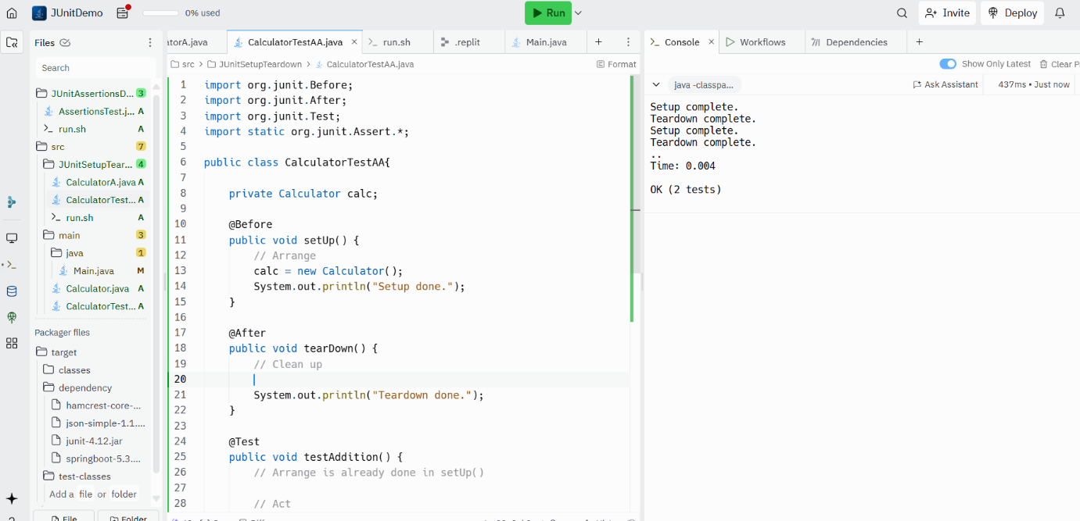

**Mockito Exercises Solutions**

Exercise:1 Mocking and Stubbing

Output

Exercise:2 Verifying Interactions

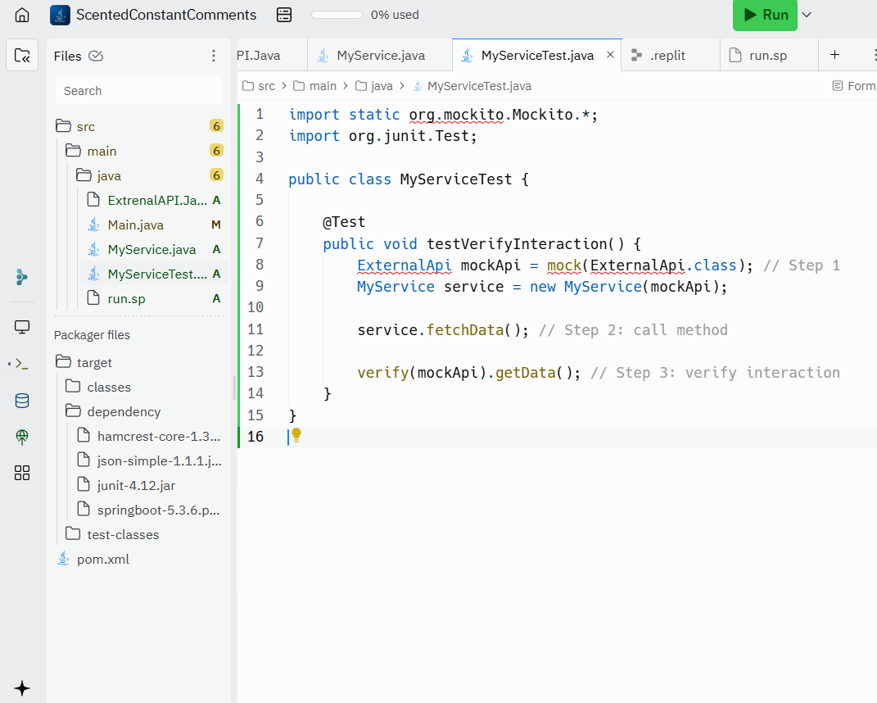

Output:

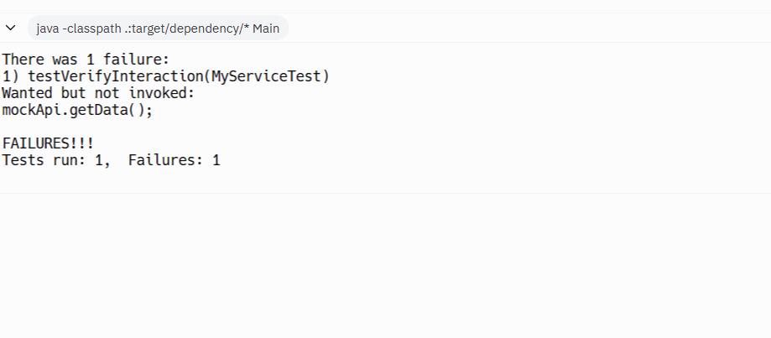

**Logging using SLF4J Solutions**

Exercise:1 Logging error messages and warning levels



